BELAL NOORY
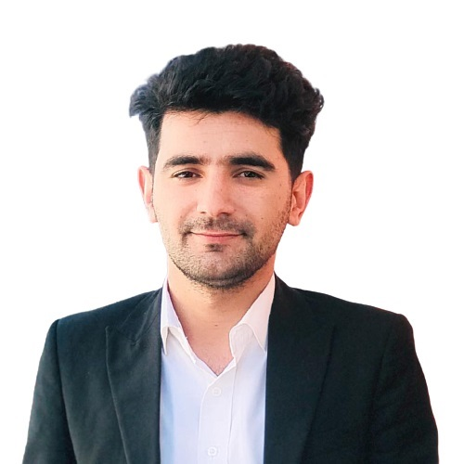
linkedin.com/in/belal-noory
belalnoory2@gmail.com
+93 748238209
Mazar-e-Sharif, AFG

SKILLS

- Project Management
- Software Development
- Front-end Development
- Back-end Development
- Mobile Development
- Technical Troubleshooting
- Database Development
- Technical Instruction
- Time management
- Flexibility

EXPERINCE

05/10/2021 - Present
Database Officer, ACTED, Mazar-e-Sharif
- Sourcing missing data and organizing it into usable formats.
- Enhancing the data collection process by applying data processing, cleansing & verifying.
- Preparing reports and visualizations of data for executive and project teams.

01/01/2021 – 09/30/2021
Computer Science Lecturer, SHARQ UNIVERSITY, Kabul
- Planned lectures, prepared extra learning materials, and supervised around 15-20 students per class.
- Instructed C++, JAVA, HTML, CSS, JavaScript, PHP, Data warehouse, and Data Mining.

06/01/2020 – 12/30/2020
Admin and Finance Officer, JUST FOR AFGHAN CAPACITY AND KNOWLEDGE – JACK, Kunduz
- Managed financial issues of the projects including budget planning, cash, and petty management.
- Vouchered financial documents, and developed paper-based and computer-based filing.
- Office management, arranged appointments, meetings, conferences, organized travel, and accommodations.
- Prepared staff’s monthly payrolls and timesheets.
- Participated in the project planning process and prepared monthly project progress report.
- Preparing monthly budgets, project progress, staff performance, monthly procurement.

11/01/2019 – 02/30/2020
ELECTRONIC MEDICAL RECORDS – EMR Officer, MEDECINS SANS FRONTIERES – MSF, Kunduz
- Conducted 8 sessions of 15 participants per session to use EMR system effectively.
- Configured the EMR system by collecting, analyzing data from doctors and nurses.
- Turned requirements into SQL queries and pass them to EMR system to work as expected.
- Developed SOP (Standard Operation Procedures) for the using of EMR system.

04/01/2019 – 08/30/2019
School Teacher, HANDS INTERNATIONAL – MHI, Kabul
- Improved and issued educational content including notes, tests, and assignments.
- Supervised classes to ensure all students are learning in a safe and productive environment.
- Organized resources for lectures and presentations, planes and implements educational activities and events.

01/01/2017 – 12/30/2018
Database Developer, AFGHAN ENGINEERING CONSULTING COMPANY, Kabul
- Led the development of database of the Firm and updates their records daily.
- Developed company portfolio website, financial management system, and project management.
- Technologies used in the development HTML, CSS, JavaScript, jQuery, Ajax, PHP, Nodejs, and Reactjs.

06/01/2016 – 12/30/2016
Software Development Lecturer, TECHBOX ACADEMY, Kabul
- Instructed Programming Concept, Programming with Java, database concepts, ICT project management,
font-end development, back-end development and mobile application development.
- Familiarized students with most advanced software, website and mobile development techniques, develops
a real software, website or mobile application for students to encourage them work further more.

01/01/2016 – 06/30/2016
IT TECHNICIAN, UNIVERSITY, Kabul
- Managed all the telecommunication issues and provided IT help desk support to all stuff.
- Installed, configured, tested, maintained, monitored, and troubleshooted end-user workstation hardware,
networked peripheral devices, and networking hardware products including scanners, printers and
telephones.

VOLUNTEERISM

01/01/2012 – 07/30/2013
Volunteer Teacher, LEARNING CENTER, Kunduz
- Issued educational content including notes, tests, and assignments, supervised classes to ensure all
students are learning in a safe and productive environment.
- Organized supplies, and resources for lectures and presentations.

EDUCATION

2015/2018
Bachelor of computer science, SHARQ University, Kabul
- Cumulative GPA: 3.47/4.0
2002/2014
High school, Ghazi Khan High School, Kunduz
- General Studies

PROJECTS

01/2021 – 03/2021
Developed Online Recruitment System for COAR NGO
Technologies Used: HTML, CSS, JavaScript, jQuery, Bootstrap, SQL Server, and PHP.
03/2021 – 07/2021
Developed E- Learning Management System for SHARQ university
Technologies Used: HTML, CSS, JavaScript, Reactjs, Nodejs, SQL Server.
08/2021 – 10/2021
Developed a website for JACK NGO
Technologies Used: HTML, CSS, JavaScript, jQuery, Bootstrap, MYSQL, and PHP.

10/2021 – 12/2021
Developed a website for AASSAA NGO
Technologies Used: HTML, CSS, JavaScript, jQuery, Bootstrap, MYSQL, and PHP.

ADDITIONAL

Languages: Pashto (Native), Persian (Fluent), English (Fluent)
Technical: Windows all versions, Microsoft Office all versions, Nodejs, Reacts ASP.net, PHP, HTML, CSS, and JavaScript, Relational Database Management Systems (RDBMS), SQL Server all versions, MYSQL, Microsoft Visual C#, Java, C++, and Android Apps using Java.

REFERENCES

RAMSSES “DENORRE”
LINE MANAGER,
MEDECINS SANS FRONTIERES (MSF)
+32 474 68 61 21
ramses.de.norre@brussels.msf.org
DR. HASHAM “SAFAR”
PROJECT MANAGER, JACK
+93 744 990 143
+93 787 047 554
Dr.safar@jack.ngo
Dr.safar@yahoo.com
EHSANULLAH “LODIN”
CHANCELORE, SHARQ UNIVERSITY
+93 786 452 464
Ehsanullah.lodin89@gmail.com

